As the security officer for Plagonia you have been tasked with setting up the security requirements for a new distribution warehouse in the UK. Plagonia sells a wide range of products through its online presence and ships to locations throughout Europe. A new warehouse complex has been acquired just outside of a major city. It consists of the warehouse itself and offices for 100 staff members. There is a large car park for the employees and loading docks for goods.
Your first task is to address the physical security of the complex. An aerial photograph of the site is shown below:
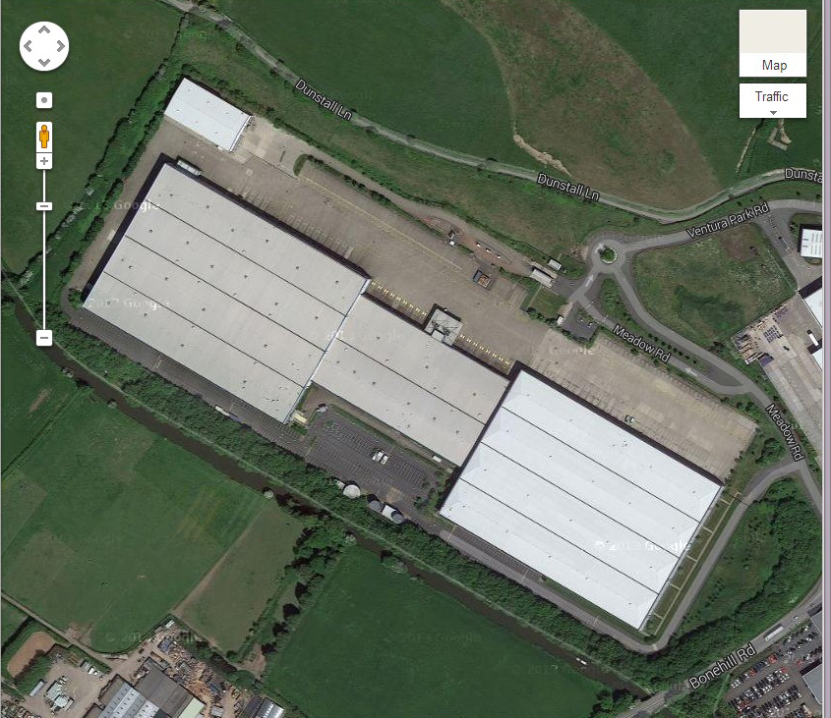
The warehouse areas are to the left and right with the office and reception area in the middle.

Q1. The value of the stock held on this site is high and restricting access is a primary concern. There will be a high volume of traffic (trucks, vans) entering and leaving the site. What are the best options for security at the site perimeter?

Q2. There is currently access to each warehouse area from the office area via simple doors. What controls could be deployed to make this more secure?

Q3. There are access doors at the rear of each warehouse area opening to the outside that have been barricaded by the previous tenant. You find out that the locks on the doors are faulty and thieves had been able to use them for access. Should you keep the doors unopenable? What other issues might this discovery raise?

Q4. The local network serves both the open-plan offices and warehouse stock monitoring and order fulfillment systems, some of which use embedded controllers. It will be a wired connection with “drops” at various locations around the building. How do you protect these network ports from misuse?

Q5. The two floors of the office and the reception area will also be served by wireless networks. The reception area will provide open wireless to allow guests and suppliers to access the internet while visiting the site. It is important for the signal not to propagate too strongly into the warehouse areas, as it has been found to interfere with some of the monitoring systems. What general procedures should you follow to set up secure wireless networks to meet these goals?

Q6.A decision is made to use smart card authentication for the office network. What protocol should you deploy on the office WLAN to support this?

