Exercise 5 - J2G245ex5

Data Capture
Answer the following questions:
- What are the characteristics of Open-ended questions?
(List at least 2 of its characteristics)
- What are the characteristics of Closed-ended questions?
(List at least 2 of its characteristics)
- If personal data is needed to be obtained from a survey. What should a privacy notice contain? Note the 5 important things to tell respondents (use the text boxes below):

- Is a privacy notice required by law? Answer YES or NO:
- From these different types of survey, Retrospective, Cross-Sectional, Longitudinal, type one of each in the boxes below that describe the survey type?
Type of Survey:
A certain point in time view from part representation of a population
Type of Survey:
Past events are captured within responses
Type of Survey:
A survey that follows same population over a period of time
- Complete the following 4 tables:
TABLE 1: Example of type of question:
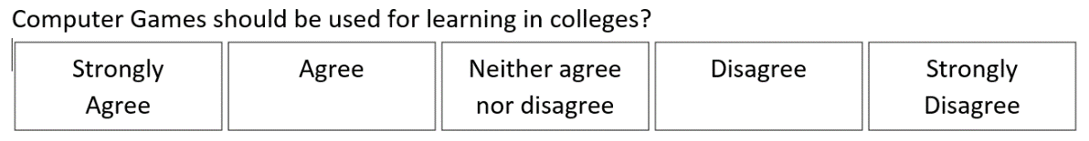
Name the type of question:
Your answer here
Characteristics of this type of questioning (pros or cons / best use):
Your answer here

TABLE 2: Example of type of question:
Name the type of question:
Your answer here
Characteristics of this type of questioning (pros or cons / best use):
Your answer here

TABLE 3: Example of type of question:
Name the type of question:
Your answer here
Characteristics of this type of questioning (pros or cons / best use):
Your answer here

TABLE 4: Example of type of question:
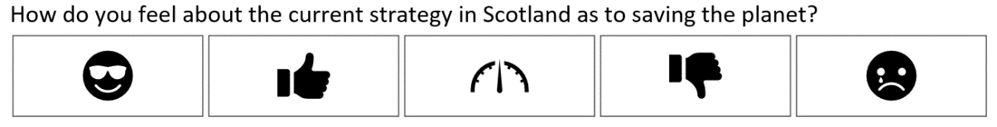
Name the type of question:
Your answer here
Characteristics of this type of questioning (pros or cons / best use):
Your answer here

- What are the 4 main types of bias that we should attempt to reduce by design of survey questioning?
- A single dataset can be manipulated to transform into a clean output dataset ready for analysis. Name the core set of activities in correct order with a brief explanation in your own words for each. Take into consideration the different parts of a dataset, such as Table, Column, Row etc.
End of exercise, save this file with your answers as J2G245ex5

