Exercise 9 - J2G245ex9

Data Quality and Management
Answer the following questions:
- Provide a definition for ‘Quality data’:
- Complete the table below, inserting at least 4 impacts of poor data quality and at least 3 benefits of high-quality data:
Examples of  Impacts of POOR data quality: | Examples of  HIGH-QUALITY data:

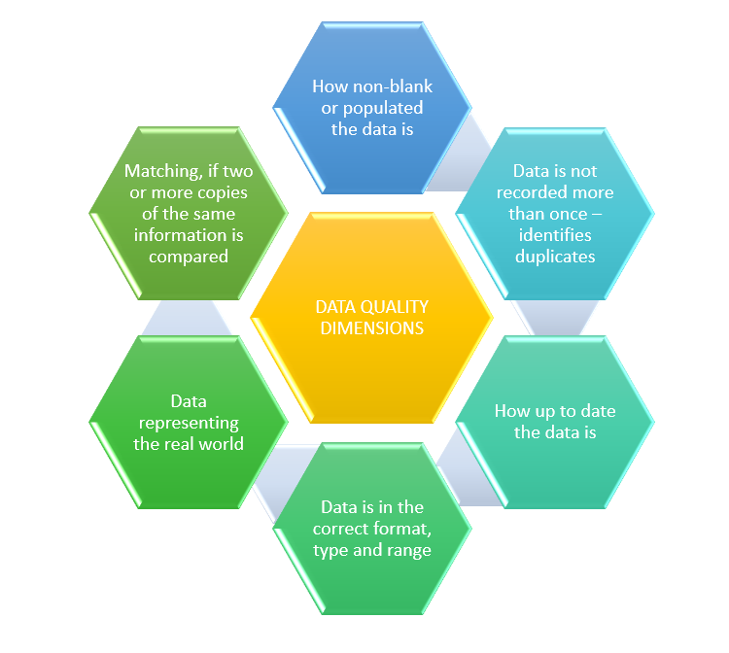
- Match the 6 different areas called the Dimensions of Data Quality to their description.
(Type the name from the list into the diagram to match the description, you are provided with one to get you started)
Validity
Accuracy
Consistency
Uniqueness
Timeliness
Completeness
[Type Here]
[Type Here]
[Type Here]
[Type Here]
[Timeliness]
[Type Here]
- Enter a brief description for each of these three different but related types of bias.
Data or Sampling bias:
Algorithmic bias:
Statistical bias:
Type of bias  (please complete): | Description provided:
 | Trends for subgroups reverse the overall norm, a statistical phenomenon leading to incorrect inferences.
 | Often through calibration or faulty detectors, a systematic issue with the collection of data.
 | Uneven distribution of modelling data caused by stereotypes of culture or gender.
 | The population to which the model is used is not represented by the model development for the dataset used.
 | Inference of a correlation where it does not exist.
 | Data or variables confirming existing human beliefs and expectations, arising from cherry-picking.
 | Concentrating upon a successful output of a process and ignoring those that don’t survive.
 | Predictive variables removed prior to the modelling process.
- Type in the cause of bias to the description in the following table:

- What can be the impacts of bias in machine learning algorithms?
(Type some examples of how bias can negatively impact in the box below)
- Respond to the following statements as to mitigating bias, with a true or false.
Statement (some are TRUE, and others are not quite - FALSE) | TRUE or FALSE
Bias can always be avoided by excluding human bias and replace with machine learning.
Review findings with subject matter experts who understand the data and are aware of how it is captured.
Exclude from the project people with differing backgrounds.
Include multiple data sources from as wide a range of providers as possible.
Seek interpretations such as data quality issues and rule these out before moving onto more complex interpretations.
Never use too much testing and validation along with transparency in the model development.
Only have experts in the main subject area as part of the team to avoid outside bias.

End of exercise, save this file with your answers as J2G245ex9

