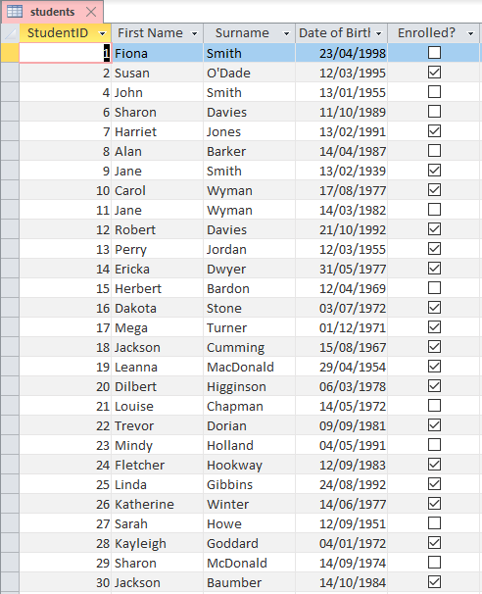
Save the table as: students
Within a database named: college

