File and Folder Management

Each set of task instructions will advise when and what name to use for saving files, the instructions contained in these task files will advise when it is the end of the task, so always scroll down to ensure completion all of the task and it is at an end.

Create the following folder structure on your hard disk drive or USB flash drive and place files generated upon completion of each task into the relevant folder. You will be required to provide screenshot evidence (see below for further instructions – IMPORTANT: read all the instructions prior to commencing the task):

Refer to the hierarchal folder structure illustration on the next page to guide you through the task.
The items shown below other items are sub-folders. Main folder, sub-folder and then sub-folders. Colours represent the same level. For example, the folder with your name has three sub-folders and the folder named Coursework has five sub-folders.

- Create a folder named: YourName_ICT5
- Create three folders within the YourName_ICT5 folder, the names of each folder should be:
Coursework, Preassess, Assess
- Within the Coursework folder, create five folders, the names of each of these folders should be:
Excel, Finding, PowerPoint, Security, Word
- Within the Preassess folder, create two folders, the names of each of these folders should be:
Answers, Notes
- Within the Assess folder, create one sub-folder named: Pending
Continued on next page …

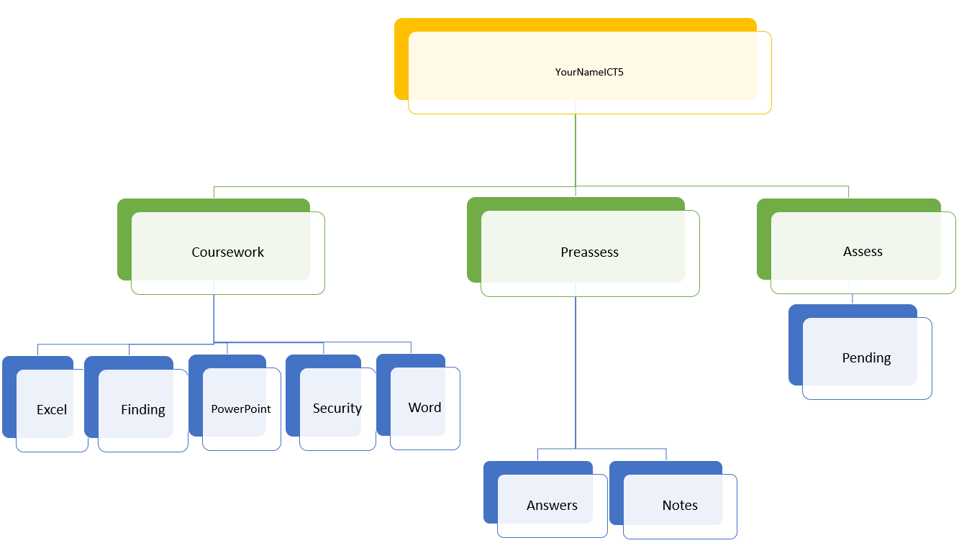

Check you have the correct folder structure. The structure is as above diagram. Remember, Microsoft Windows puts folder and files names into alphabetical order or number order – the exact order of folders is not important, just ensure they are correctly named and within the correct folder as shown.

Continued on next page …
Capture a screenshot of the folder structure as required in the previous set of instructions.

Insert screenshot here:

Continued on next page …

Now change the folder structure as follows – ensure a screenshot is captured prior to each of the following and a screenshot after, as directed hereunder (before and after):

Changing a folder name
- Screenshot prior to changing the name of the folder
Insert screenshot here:

- The folder within the Coursework folder named Finding should now be named: Info
- Screenshot after changing the name of the folder
Insert screenshot here:

Continued on next page …

Removal of a folder from the structure
- Screenshot prior to the removal of a folder
Insert screenshot here:

- Delete the “Pending” folder located within the Assess folder
- Screenshot showing the folder removed from the structure
Insert screenshot here:

If you have any other naming system or folder structure, change it to now be as requested within this task

Continued on next page …

Using the same Word document containing the screenshot evidence for this task, capture one last screenshot of the folder structure now that the task is complete. The screenshot evidence for everything in this task should have the ‘before’ and ‘after’ events. It is impossible to see every part of every task being performed; this is the reason for screenshot evidence.

Ensure you save this Word document file to the Answers folder you should have created, naming the file: task1

End of task, continue to next task.

